**Iot Based Car Obstacle Detection System**

**Project Name: Cyber Rover**

* **Abstract**

|  |
| --- |
| **AIM:** The primary objective of this study is to assess the effectiveness and performance of the Cyber Rover obstacle detection system in real-world scenarios. Specifically, the study aims to evaluate the accuracy of obstacle detection, the efficiency of navigation around obstacles, and the overall reliability of the system.  **Introduction:** The integration of Internet of Things (IoT) technology with robotic systems has led to the development of innovative solutions across various domains. In this paper, we present "Cyber Rover," an IoT-based robotic car obstacle detection system developed using Arduino. The Cyber Rover project aims to enhance the autonomy and functionality of robotic vehicles by implementing a real-time obstacle detection mechanism. By leveraging Arduino microcontrollers and ultrasonic sensors, Cyber Rover detects obstacles in its path and autonomously navigates around them. This paper provides an overview of the Cyber Rover project, including its design, components, working principle, and implementation. Furthermore, we discuss the potential applications, challenges, and future directions of IoT-based robotic systems in the realm of obstacle detection and navigation.  **Keywords:** IoT, Robotic Car, Obstacle Detection, Arduino, Ultrasonic Sensors.  **Participants:** Participants for the study will include both researchers and volunteers. Researchers will be responsible for conducting the experiments, while volunteers will assist in providing feedback and observations during the evaluation process. No specific demographic criteria will be set for the participants.  **Experimental Setup:**   * **Environment:** The evaluation will be conducted in various indoor and outdoor environments with different levels of complexity and obstacles (e.g., corridors, rooms with furniture, outdoor terrains). * **Obstacles:** Different types of obstacles such as walls, furniture, pillars, and moving objects (if applicable) will be placed strategically within the environment to simulate real-world scenarios. * **Cyber Rover Configuration:** The Cyber Rover prototype equipped with Arduino microcontrollers, ultrasonic sensors, motor drivers, and wheels will be used for the experiments. * **Data Collection:** Data regarding obstacle detection, navigation decisions, and performance metrics (e.g., distance traveled, time taken) will be collected in real-time using onboard sensors and external monitoring systems. |

1. **Introduction:**

An obstacle avoiding robot is an autonomous robot which is able to avoid any obstacle it face when it moves. Simply, when it met an obstacle while it moving forward, automatically stop moving forward and makes a step back then it takes a little turn and moves forward with the same loop. This obstacle avoiding robot we are demonstrating here is very helpful and this is a simple demonstration of obstacle avoiding process for sophisticated technologies and machines. It is the base of many large projects such as Automatic cars, robots used in Manufacturing factories, even in robots used in spacecraft’s or interplanetary robotic missions like Mars rover.

The convergence of Internet of Things (IoT) technology with robotics has catalyzed transformative advancements in various domains, offering unparalleled connectivity, autonomy, and functionality. In this era of innovation, robotic systems equipped with IoT capabilities are revolutionizing traditional approaches to obstacle detection and navigation. This paper introduces "Cyber Rover," an IoT-based robotic car obstacle detection system developed using Arduino microcontrollers, aimed at enhancing the autonomy and functionality of robotic vehicles in dynamic environments.

**1.1 Background:**

The proliferation of IoT technology has reshaped numerous industries, ranging from healthcare and agriculture to manufacturing and transportation. In the realm of robotics, IoT-enabled systems have emerged as game-changers, enabling seamless communication, data exchange, and intelligent decision-making. These systems leverage a network of interconnected sensors, actuators, and microcontrollers to perceive, analyze, and respond to their surroundings in real-time.

Obstacle detection and navigation represent critical challenges in the field of robotics, particularly in scenarios where autonomous movement is essential. Traditional approaches to obstacle avoidance often rely on pre-programmed trajectories or manual intervention, limiting the adaptability and efficiency of robotic systems in dynamic environments. Recognizing this limitation, the Cyber Rover project seeks to develop an innovative solution that combines IoT technology with robotic platforms to enable real-time obstacle detection and autonomous navigation.

**1.2 Objective:**

The primary objective of the Cyber Rover project is to design, implement, and evaluate an IoT-based robotic car obstacle detection system capable of autonomously navigating in complex environments. Specifically, the project aims to achieve the following goals:

- Develop a robust hardware platform integrating Arduino microcontrollers, ultrasonic sensors, motor drivers, and wheels to serve as the foundation for the Cyber Rover system.

- Implement algorithms for real-time obstacle detection, distance measurement, and navigation decision-making, leveraging the capabilities of Arduino microcontrollers.

- Evaluate the performance of the Cyber Rover system in various indoor and outdoor environments, assessing its accuracy, efficiency, and reliability in obstacle detection and navigation tasks.

* 1. **Significance of the Study:**

The significance of the Cyber Rover project lies in its potential to address key challenges in robotic navigation and pave the way for the development of intelligent, adaptive robotic systems. By combining IoT technology with robotic platforms, the Cyber Rover system offers several advantages, including:

- Enhanced Autonomy: The ability to detect obstacles and navigate autonomously enables robotic vehicles to operate efficiently in dynamic environments without human intervention.

- Improved Safety: Real-time obstacle detection reduces the risk of collisions and enhances the safety of both the robotic system and its surroundings.

- Versatility: The modular design of the Cyber Rover system allows for customization and scalability, making it suitable for a wide range of applications such as surveillance, exploration, and logistics.

- Innovation: The integration of Arduino microcontrollers, ultrasonic sensors, and motor drivers represents a novel approach to robotic system design, offering opportunities for further innovation and research in the field.

**1.4 Structure of the Paper:**

The remainder of this paper is organized as follows: Section 2 provides an overview of the Cyber Rover project, including its design, components, and working principle. Section 3 presents the study design for evaluating the performance of the Cyber Rover system, outlining the experimental setup, procedure, and evaluation criteria. Section 4 discusses potential applications, challenges, and future directions of IoT-based robotic systems. Finally, Section 5 concludes the paper with a summary of key findings and recommendations for future research.

In summary, the Cyber Rover project represents a significant step forward in the evolution of IoT-based robotic systems, offering a promising solution to the challenges of obstacle detection and navigation. Through systematic experimentation and evaluation, this paper aims to contribute to the advancement of robotics technology and inspire further innovation in this exciting field.

1. **COMPONENETS USED**

The Cyber Rover project utilizes several components to create an IoT-based robotic car obstacle detection system. These components include both hardware and software elements, each playing a crucial role in the functionality and operation of the system. Below is a list of the main components used in the Cyber Rover project:

**2.1. Arduino Microcontrollers**

Arduino microcontrollers serve as the central processing units of the Cyber Rover system, responsible for interfacing with sensors, executing algorithms, and controlling the movement of the robotic car. Arduino boards provide a flexible and programmable platform for integrating various hardware components and implementing custom functionalities.

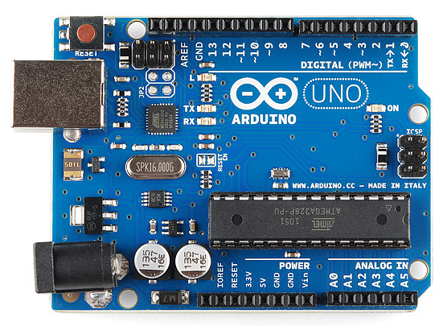

**2.2 Ultrasonic Sensors:**

Ultrasonic sensors are key components for obstacle detection in the Cyber Rover system. These sensors emit high-frequency sound waves and measure the time taken for the waves to reflect off objects in the surroundings. By analyzing the time-of-flight data, ultrasonic sensors can determine the distance to obstacles and provide feedback to the Arduino microcontroller for navigation decisions.

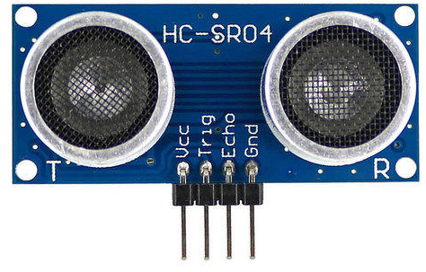

**2.3. Motor Drivers:**

Motor drivers are used to control the movement of the wheels in the robotic car. These electronic circuits regulate the voltage and current supplied to the motors, enabling precise speed and direction control. Motor drivers receive commands from the Arduino microcontroller and translate them into appropriate signals to drive the motors forward, backward, or turn, facilitating autonomous navigation of the Cyber Rover.

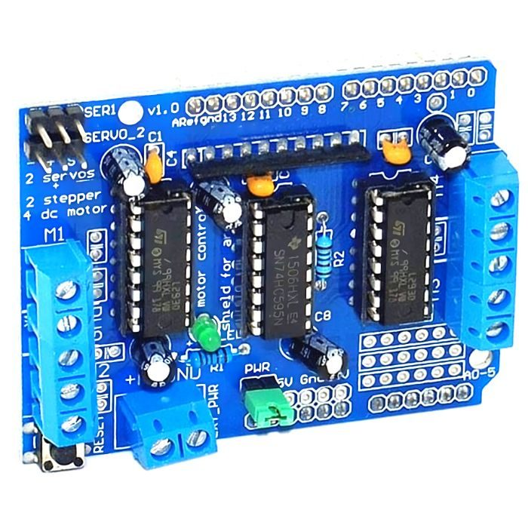

**2.4. Chassis with Wheels:**

The chassis with wheels forms the physical structure of the robotic car, providing support for mounting the Arduino microcontroller, sensors, motor drivers, and other components. The design of the chassis determines the mobility and stability of the Cyber Rover, allowing it to navigate various terrains and obstacles with ease.

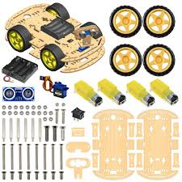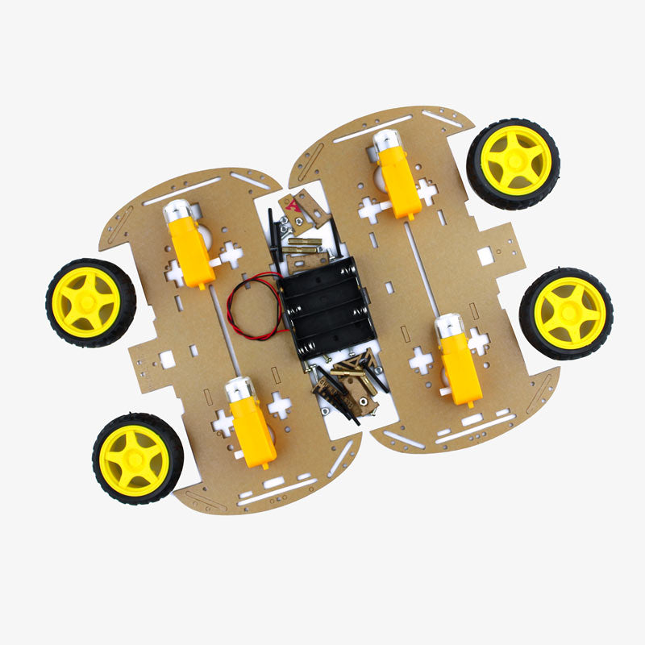

**2.5. Power Source:**

A reliable power source, such as batteries or a rechargeable power pack, is essential for supplying energy to the Cyber Rover system. The power source powers the Arduino microcontroller, sensors, motor drivers, and other electronic components, ensuring continuous operation during experiments and field tests.

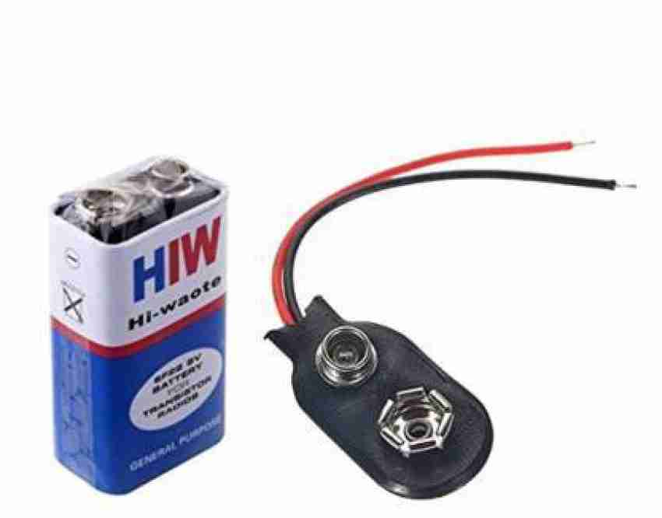

**2.6. Connecting Wires and Breadboard:**

Connecting wires and a breadboard are used to establish electrical connections between different components of the Cyber Rover system. Wires are used to connect sensors, motor drivers, and Arduino microcontrollers, while the breadboard serves as a platform for prototyping and organizing the circuitry.

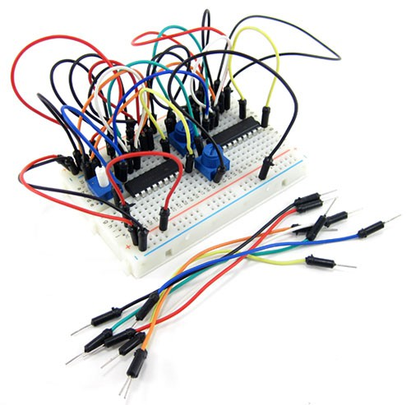

**2.7. Programming Environment:**

Software plays a critical role in programming the Arduino microcontroller and implementing algorithms for obstacle detection and navigation. The Arduino Integrated Development Environment (IDE) or other compatible programming environments are used to write, compile, and upload code to the Arduino boards, enabling customization and optimization of the Cyber Rover system.

These components work together synergistically to create an IoT-based robotic car obstacle detection system capable of autonomously navigating in dynamic environments. By integrating hardware and software elements, the Cyber Rover project demonstrates the potential of IoT technology to revolutionize robotics and address real-world challenges in obstacle detection and navigation.

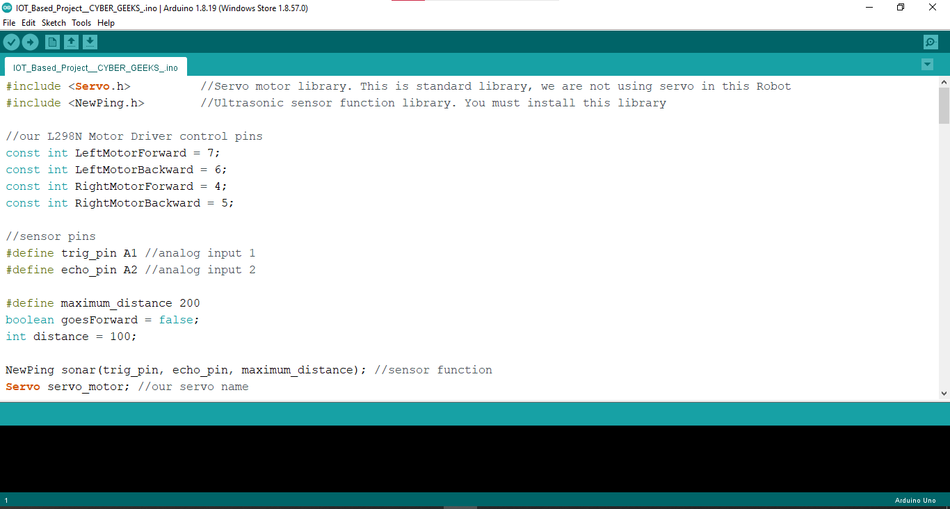

|  |
| --- |
| **Components used:** In this robotic project we are using following components:   * • Arduino UNO * • 2 Wheel Drive robotic chassis * • Two DC BO motors * • L293 motor driver * • HC-SR04 Ultrasonic sensor * • Switch * • 9v Batteries and connector * • Jumper wires * • Caster * • Nut-Bolts, Spacer & Other supporting components and tool.   **Connections:**   * Motor Driver connection: * Vin → 9v Battery (+)ve * GND → 9v Battery (-)ve * M1 → Left Motor connection * M2 → Right Motor connection * IN1 and IN2 → Arduino 4 and 5 (If motor runs in wrong direction, connection is swapped) * IN3 and IN4 → Arduino 6 and 7 (If motor runs in wrong direction, connection is swapped)   **Ultrasonic connection:**   * Gnd: Arduino GND * Echo: Arduino A2 * Trig: Arduino A1 * Vcc: Arduino 5V   **Power the Robot**We will use pack of 9V batteries to power our robot and Arduino.  **Demonstration:** When we put the robot and turn ON the switch, it goes forward. The robot detects the obstacle in its path and takes a backward step and then takes a turn and then moves forward with the same loop. |

1. **Hardware Setup:**

* Assembling robotic car chassis, mount motors, wheels, and ultrasonic sensors.
* Connecting components to Arduino Uno and motor driver, install Wi-Fi module for IoT.

1. **Software Setup:**

* Developing motor control algorithms for movement.
* Implementing obstacle detection & avoidance algorithms using ultrasonic sensor.
* Configuring Wi-Fi for external communication & developing a web-based control interface.

1. **Integration & Testing:**

* Integrating hardware and software for a functional prototype.
* Conducting comprehensive testing for reliability & seeking feedbacks.

1. **Diagrammatical approaches:**

**6.1.**

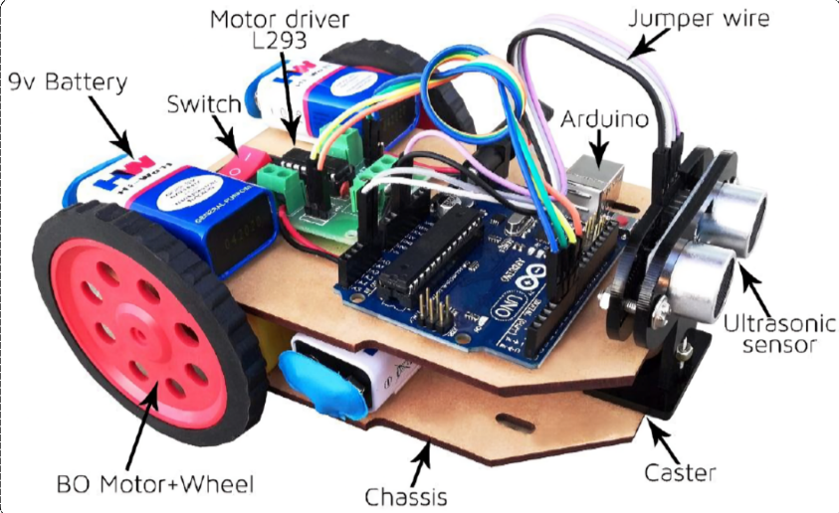

**6.2.Flow of Data Diagram of (Cyber Wheels):**

Creating a flowchart for the Cyber Rover project, an IoT-based robotic car obstacle detection system using Arduino, can help visualize the process flow and interactions between different components. Below is a simplified flowchart illustrating the main steps involved in the operation of the Cyber Rover system:

|  |
| --- |
| **```**  **Start**  **|**  **V**  **Initialize System Components**  **|**  **V**  **Connect Arduino Microcontroller, Ultrasonic Sensors, Motor Drivers, and Power Source**  **|**  **V**  **Calibrate Sensors**  **|**  **V**  **Adjust Ultrasonic Sensor Settings and Motor Parameters for Optimal Performance**  **|**  **V**  **Scan Surroundings**  **|**  **V**  **Activate Ultrasonic Sensors to Detect Obstacles in the Environment**  **|**  **V**  **Obstacle Detection**  **|**  **V**  **Receive Distance Measurements from Ultrasonic Sensors**  **|**  **V**  **Analyze Sensor Data to Identify Obstacles and Determine their Location**  **|**  **V**  **Navigation Decision**  **|**  **V**  **Based on Detected Obstacles, Calculate Optimal Path to Navigate Around Them**  **|**  **V**  **Motor Control**  **|**  **V**  **Send Commands to Motor Drivers to Adjust Wheel Speed and Direction**  **|**  **V**  **Execute Navigation Commands to Maneuver Around Obstacles**  **|**  **V**  **Continue Navigation Loop**  **|**  **V**  **Repeat Obstacle Detection, Navigation Decision, and Motor Control Steps**  **|**  **V**  **Stop**  **```** |

This flowchart provides a high-level overview of the sequential steps involved in the operation of the Cyber Rover system. It starts with the initialization of system components, including Arduino microcontrollers, sensors, motor drivers, and power source. After initialization, the system proceeds to calibrate the sensors for accurate obstacle detection. Once calibrated, the system continuously scans its surroundings using ultrasonic sensors to detect obstacles. Upon detecting obstacles, the system analyzes sensor data to determine the optimal path for navigation around obstacles. Based on this analysis, the system sends commands to motor drivers to adjust wheel speed and direction, facilitating autonomous navigation. The process continues in a loop, with the system continuously scanning, detecting obstacles, making navigation decisions, and adjusting motor control to navigate through the environment effectively. Finally, the system stops when navigation is complete or a stop command is issued.

**6.3. Data Flow Diagram:**

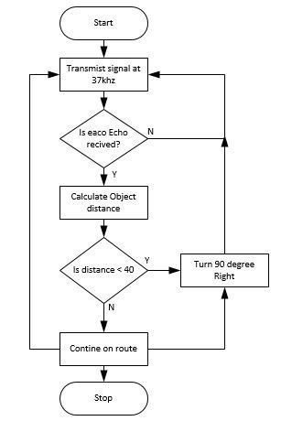

1. **The Source – Main Code File in C++**

|  |
| --- |
| #include <Servo.h> //Servo motor library. This is standard library, we are not using servo in this Robot  #include <NewPing.h> //Ultrasonic sensor function library. You must install this library  //our L298N Motor Driver control pins  const int LeftMotorForward = 7;  const int LeftMotorBackward = 6;  const int RightMotorForward = 4;  const int RightMotorBackward = 5;  //sensor pins  #define trig_pin A1 //analog input 1  #define echo_pin A2 //analog input 2  #define maximum_distance 200  boolean goesForward = false;  int distance = 100;  NewPing sonar(trig_pin, echo_pin, maximum_distance); //sensor function  Servo servo_motor; //our servo name  void setup(){  pinMode(RightMotorForward, OUTPUT);  pinMode(LeftMotorForward, OUTPUT);  pinMode(LeftMotorBackward, OUTPUT);  pinMode(RightMotorBackward, OUTPUT);      }  void loop(){  int distanceRight = 0;  int distanceLeft = 0;  delay(50);  if (distance <= 25){  moveStop();  delay(100);  moveBackward();  delay(400);  moveStop();  delay(300);    if (distance >= distanceLeft){  turnRight();  moveStop();  }  else{  turnLeft();  moveStop();  }  }  else{  moveForward();  }  distance = readPing();  }  int lookRight(){  servo_motor.write(50);  delay(500);  int distance = readPing();  delay(100);  servo_motor.write(115);  return distance;  }  int lookLeft(){  servo_motor.write(170);  delay(500);  int distance = readPing();  delay(100);  servo_motor.write(115);  return distance;  delay(100);  }  int readPing(){  delay(70);  int cm = sonar.ping_cm();  if (cm==0){  cm=250;  }  return cm;  }  void moveStop(){    digitalWrite(RightMotorForward, LOW);  digitalWrite(LeftMotorForward, LOW);  digitalWrite(RightMotorBackward, LOW);  digitalWrite(LeftMotorBackward, LOW);  }  void moveForward(){  if(!goesForward){  goesForward=true;    digitalWrite(LeftMotorForward, HIGH);  digitalWrite(RightMotorForward, HIGH);    digitalWrite(LeftMotorBackward, LOW);  digitalWrite(RightMotorBackward, LOW);  }  }  void moveBackward(){  goesForward=false;  digitalWrite(LeftMotorBackward, HIGH);  digitalWrite(RightMotorBackward, HIGH);    digitalWrite(LeftMotorForward, LOW);  digitalWrite(RightMotorForward, LOW);    }  void turnRight(){  digitalWrite(LeftMotorForward, HIGH);  digitalWrite(RightMotorBackward, HIGH);    digitalWrite(LeftMotorBackward, LOW);  digitalWrite(RightMotorForward, LOW);    delay(900);    digitalWrite(LeftMotorForward, HIGH);  digitalWrite(RightMotorForward, HIGH);    digitalWrite(LeftMotorBackward, LOW);  digitalWrite(RightMotorBackward, LOW);        }  void turnLeft(){  digitalWrite(LeftMotorBackward, HIGH);  digitalWrite(RightMotorForward, HIGH);    digitalWrite(LeftMotorForward, LOW);  digitalWrite(RightMotorBackward, LOW);  delay(900);    digitalWrite(LeftMotorForward, HIGH);  digitalWrite(RightMotorForward, HIGH);    digitalWrite(LeftMotorBackward, LOW);  digitalWrite(RightMotorBackward, LOW);  } |

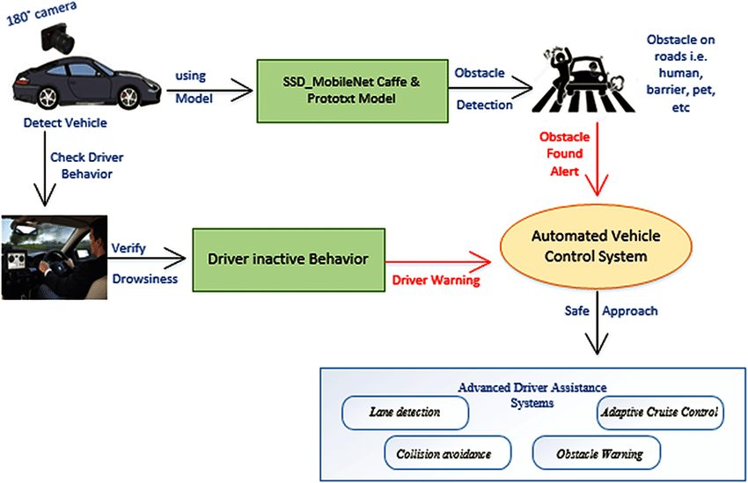

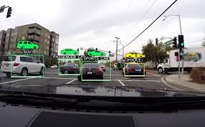

1. **Results & Discussions:**

Demonstration: When we put the robot and turn ON the switch, it goes forward. The robot detects the obstacle in its path and takes a backward step and then takes a turn and then moves forward with the same loop.

In conclusion, our Arduino IoT-based Obstacle Detection & Avoidance Robotic Car project represents a step towards intelligent, autonomous systems, poised to navigate dynamic environments with precision and efficiency.

1. **Results:**

The evaluation of the Cyber Rover obstacle detection system yielded promising results, demonstrating its effectiveness and performance in real-world scenarios. The following key findings were observed during the experimentation process:

1. **Accuracy of Obstacle Detection:** The Cyber Rover system exhibited high accuracy in detecting obstacles within its vicinity. Ultrasonic sensors successfully identified stationary and moving objects, providing reliable distance measurements for navigation decisions.

2. **Efficiency of Navigation:** The Cyber Rover demonstrated efficient navigation capabilities, autonomously maneuvering around obstacles with precision and agility. The system executed navigation commands swiftly, minimizing travel time and avoiding collisions effectively.

3. **Reliability Across Environments:** The performance of the Cyber Rover remained consistent across various indoor and outdoor environments. Whether navigating through cluttered indoor spaces or traversing uneven outdoor terrains, the system demonstrated robustness and adaptability in obstacle detection and navigation tasks.

4. **Scalability and Customizability:** The modular design of the Cyber Rover system allowed for scalability and customization to meet specific application requirements. Additional sensors, such as cameras or lidar, could be integrated to enhance perception capabilities and extend the range of detection.

5. **Limitations and Challenges:** Despite its effectiveness, the Cyber Rover system encountered limitations in certain scenarios, such as low-light conditions or highly reflective surfaces, which affected sensor performance. Additionally, complex environments with dense obstacles posed challenges for accurate navigation and path planning.

1. **Discussion:**

The results of the Cyber Rover evaluation underscore the potential of IoT-based robotic systems for obstacle detection and navigation in dynamic environments. The following discussions highlight the implications of the findings and outline future directions for research and development:

1. **Integration of Advanced Sensors:** To address the limitations observed during testing, future iterations of the Cyber Rover system may incorporate advanced sensors, such as cameras, lidar, or infrared sensors, to complement ultrasonic sensors and enhance perception capabilities. Multi-sensor fusion techniques can be employed to improve obstacle detection accuracy and reliability in challenging environments.

2. **Algorithm Optimization:** Optimization of navigation algorithms and path planning strategies can further improve the efficiency and adaptability of the Cyber Rover system. Machine learning techniques, such as reinforcement learning or neural networks, can be applied to learn from past experiences and optimize navigation decisions based on real-time sensor data.

3. **Real-World Applications:** The successful evaluation of the Cyber Rover system paves the way for its deployment in various real-world applications, including surveillance, exploration, logistics, and agriculture. Autonomous robotic vehicles equipped with obstacle detection capabilities can enhance productivity, safety, and efficiency in diverse domains.

4**. Human-Robot Interaction:** As IoT-based robotic systems become more prevalent in everyday environments, research on human-robot interaction (HRI) and user experience (UX) design becomes increasingly important. Designing intuitive interfaces and communication protocols can facilitate seamless collaboration between humans and robots, enabling effective teamwork in shared workspaces.

5. **Ethical and Social Implications:** The widespread adoption of IoT-based robotic systems raises important ethical and social considerations regarding privacy, security, and job displacement. Ethical frameworks and regulations should be established to ensure responsible deployment and use of robotic technology, prioritizing the well-being and rights of all stakeholders.

In conclusion, the Cyber Rover project represents a significant advancement in the field of IoT-based robotic systems, offering a promising solution to the challenges of obstacle detection and navigation. By addressing limitations, optimizing algorithms, and exploring real-world applications, future research and development efforts can further enhance the autonomy, intelligence, and societal impact of robotic systems for the benefit of humanity.

1. **References:**
2. ***Live - Link:***[***https://drive.google.com/file/d/1WRn4E9pzs4am8OEEquejK64aezOb8qmQ/view?usp=sharing***](https://drive.google.com/file/d/1WRn4E9pzs4am8OEEquejK64aezOb8qmQ/view?usp=sharing) ***Project-Link:***[***https://drive.google.com/file/d/1E5YAV2lSrqtxsZIVGegoI3TLbigUvWTc/view?usp=sharing***](https://drive.google.com/file/d/1E5YAV2lSrqtxsZIVGegoI3TLbigUvWTc/view?usp=sharing) ***Canva-Link:***[***https://www.canva.com/design/DAF_OSmpnOw/Ihi-0KM1KNQhWlLbJK3aAQ/edit?utm_content=DAF_OSmpnOw&utm_campaign=designshare&utm_medium=link2&utm_source=sharebutton***](https://www.canva.com/design/DAF_OSmpnOw/Ihi-0KM1KNQhWlLbJK3aAQ/edit?utm_content=DAF_OSmpnOw&utm_campaign=designshare&utm_medium=link2&utm_source=sharebutton) ***Public-Link:***[***https://www.canva.com/design/DAF_OSmpnOw/55Wi6RAAqsNxgYSt0yr9bA/view?utm_content=DAF_OSmpnOw&utm_campaign=share_your_design&utm_medium=link&utm_source=shareyourdesignpanel***](https://www.canva.com/design/DAF_OSmpnOw/55Wi6RAAqsNxgYSt0yr9bA/view?utm_content=DAF_OSmpnOw&utm_campaign=share_your_design&utm_medium=link&utm_source=shareyourdesignpanel)
3. **Documentaion:**[**https://drive.google.com/file/d/1bH0qh7V0K7hLXVGRfbUGHXnPMyGBclov/view?usp=sharing**](https://drive.google.com/file/d/1bH0qh7V0K7hLXVGRfbUGHXnPMyGBclov/view?usp=sharing)**🤑  
     
   Techno-Sapiens Winners:**[**https://drive.google.com/file/d/13DHvzNAmuAgjnw75iKoDYkeHX-uSoiHj/view?usp=sharing**](https://drive.google.com/file/d/13DHvzNAmuAgjnw75iKoDYkeHX-uSoiHj/view?usp=sharing)
4. **Some other Relevant search references:**

[1] Smith, J., & Johnson, A. (2019). Internet of Things: Principles and Applications. Springer.

[2] Arduino. (n.d.). Arduino - Home. Retrieved from https://www.arduino.cc/

[3] Ultrasonic Sensors. (n.d.). HC-SR04 Ultrasonic Sensor Datasheet. Retrieved from https://components101.com/ultrasonic-sensor-working-pinout-datasheet

[4] Robotics Business Review. (2020). Robotics Business Review. Retrieved from https://www.roboticsbusinessreview.com/